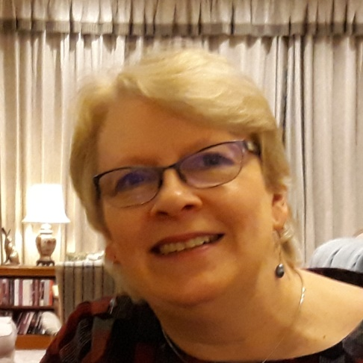

Biography
Jennifer Giles is a Curator (Scottish Communities & Organisations) in the National Library of Scotland’s General Collections Team. Her work comprises collecting and promoting the Library’s twentieth and twenty-first century published local, community and Gaelic collections. She has previously spent many years in the Library working to implement the legal deposit legislation, which is the unique feature that enables the Library to build and retain its extensive UK and Irish collections.

Abstract of Talk
Jennifer will introduce the wide range of publicly available collections that the National Library of Scotland holds, such as local magazines, booklets and event programmes from across Scotland, as well as the latest academic research journals and government publications from the UK and Ireland.
The Library’s status as a legal deposit library means that the national collection now numbers in excess of 29 million items, dating back to 1710, so there is much of relevance to community and local history researchers on all topics. Significant collections have been digitised, such as Post Office directories and maps, and are available on its website. In addition, the Library also purchases online subscription packages to newspapers and journals which are available to remote users via the website, and Jennifer will explain how to access them.

